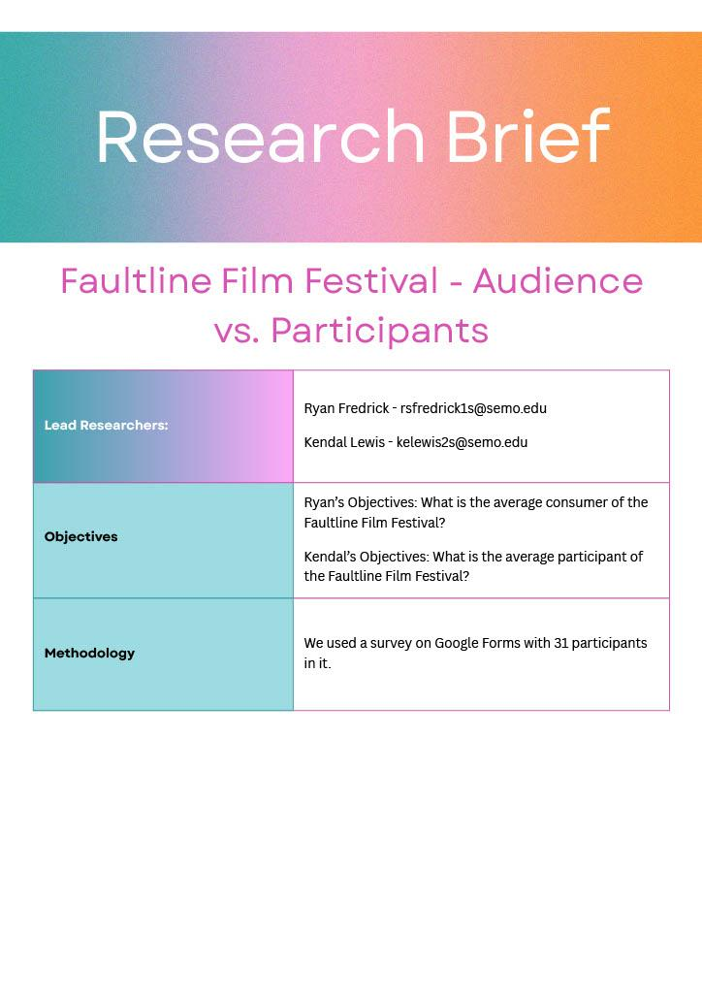
EXECUTIVE SUMMARY:

This section serves as a briefing of the rest of the report.
Through our survey, we found that in terms of the average audience member of the Fault Line Film Festival, most care a lot about diversity and inclusion. Most would also attend the festival again, but many people did not know about the festival, suggesting that marketing should be increased.
We also gathered intel on people who have submitted their films to the Fault Line Film Festival and found that most people who have submitted a film found it extremely hard to neutral-feeling on the process. No participant rated the experience as “easy”, suggesting that the application process should be refined.

TABLE OF CONTENTS:

Title Page 1
Executive Summary 2
Table of Contents 3
Introduction 4
Methods 5-6
Analysis 7-15
Team Information 16
Appendix 16-22

INTRODUCTION:

The Fault Line Film Festival is an emblem of creativity and cinematic excellence in our community. Year after year, cinephiles and filmmakers eagerly anticipate its arrival, celebrating the artistry and innovation showcased on its screens. As we embark on this journey of media analytics, our focus turns to dissecting the intricate dynamics that propel this festival to success. As we delve deeper into media analytics, several questions emerge, beckoning us to unravel the underlying factors contributing to the Fault Line Film Festival's acclaim. What drives audiences to attend the festival year after year? What do the audiences who care about the Fault Line Film Festival want to see from their shows? What do they care about? What do the people participating in submitting films believe about the submission process? Or is the institution fair when assessing films? To comprehend the festival's success comprehensively, we must explore an array of metrics, ranging from audience demographics and engagement levels to filmmaker satisfaction and industry recognition. By examining these facets, we can gain valuable insights into the festival's impact on both creators and consumers of cinematic content. In the forthcoming sections of this report, we embark on a journey of exploration and discovery, guided by our research goals. We seek to unravel the intricacies of the Fault Line Film Festival, shedding light on its significance in our media landscape and unveiling the driving forces behind its enduring allure. Through meticulous analysis and interpretation, we aim to paint a comprehensive picture of the festival, offering valuable insights to the institution and film festival enthusiasts.

Fault Line Film Festival Audience and Participant Analysis

Research Methods

By
Ryan Fredrick
Kendal Lewis

Methods –
- We created a Google Form with 13 items to analyze people in the Southeast Missouri region’s viewing habits regarding the Fault Line Film Festival. We had 6 questions related to audience personality, 5 questions related to those who have submitted films to the Fault Line Film Festival, and 2 questions about demographics.
o The survey was posted on April 24th, 2024, and was available until May 1st, 2024.
o The survey was posted on our social media with Cape Girardeau-centered followers on April 24th, 2024.
o A QR code for the survey was placed at the University Center, Towers Complex, and Grauel building on April 25th, 2024.
- The survey was created and administered using Google Forms.
- The data was analyzed using Google Sheets.

Demographic Breakdowns –
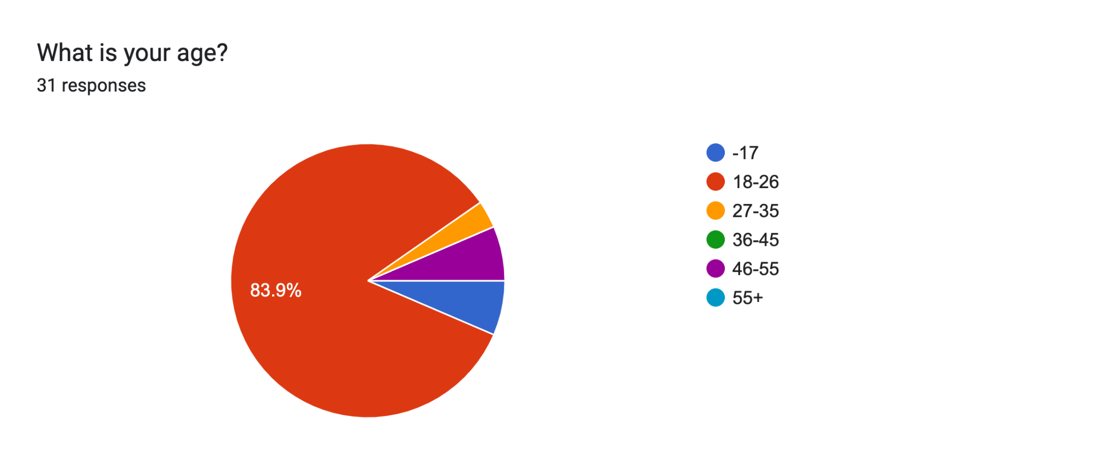
- 6.5% of participants were 17 or younger
- 83.9% of participants were 18-26
- 3.2% of participants were 27-35
- 0% of participants were 36-45
- 6.5% of participants were 46-55
- 0% of participants were above 55
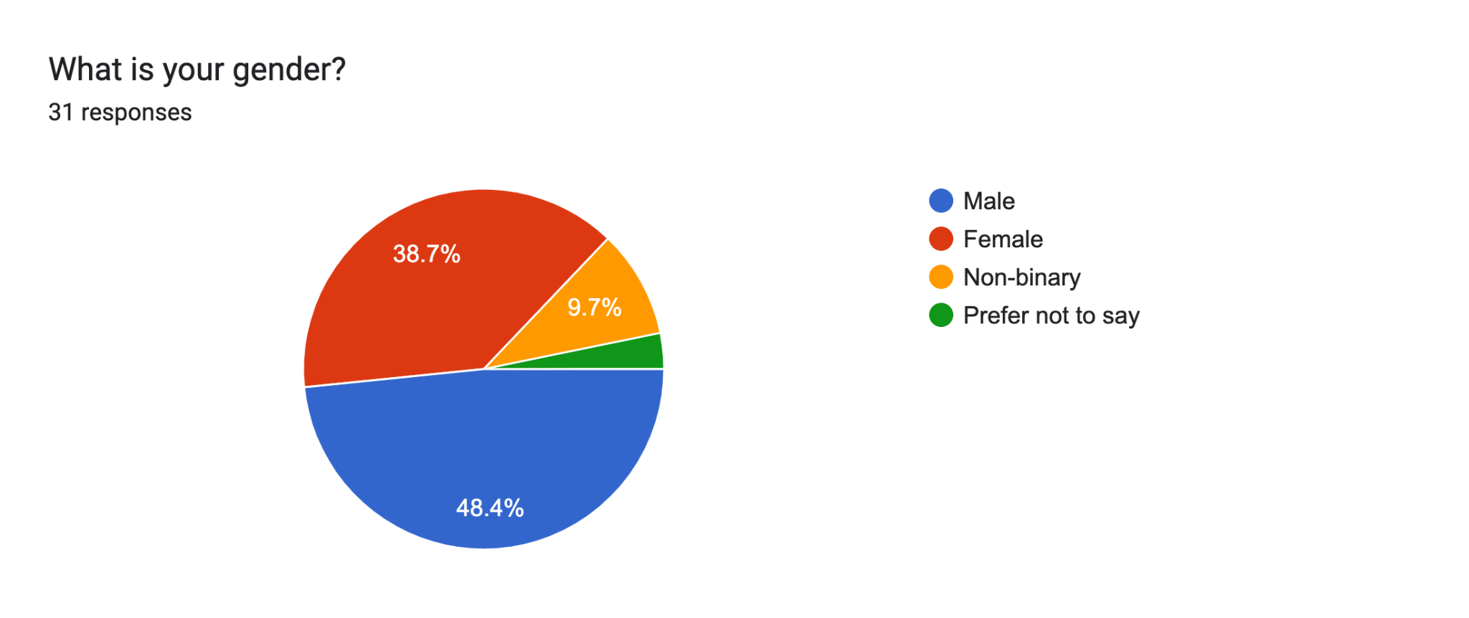
- 48.4% of participants identify as male
- 38.7% of participants identify as female
- 9.7% of participants identify as non-binary
- 3.2% of participants preferred not to say
ANALYSIS
Goals:
Ryan’s goal was to see the views held by the average Fault Line Film Festival attendee. Kendal’s goal is to find select people who submit to Fault Line to get their thoughts and views on it through this survey.

Average Fault Line Consumer:
FINDING ONE:
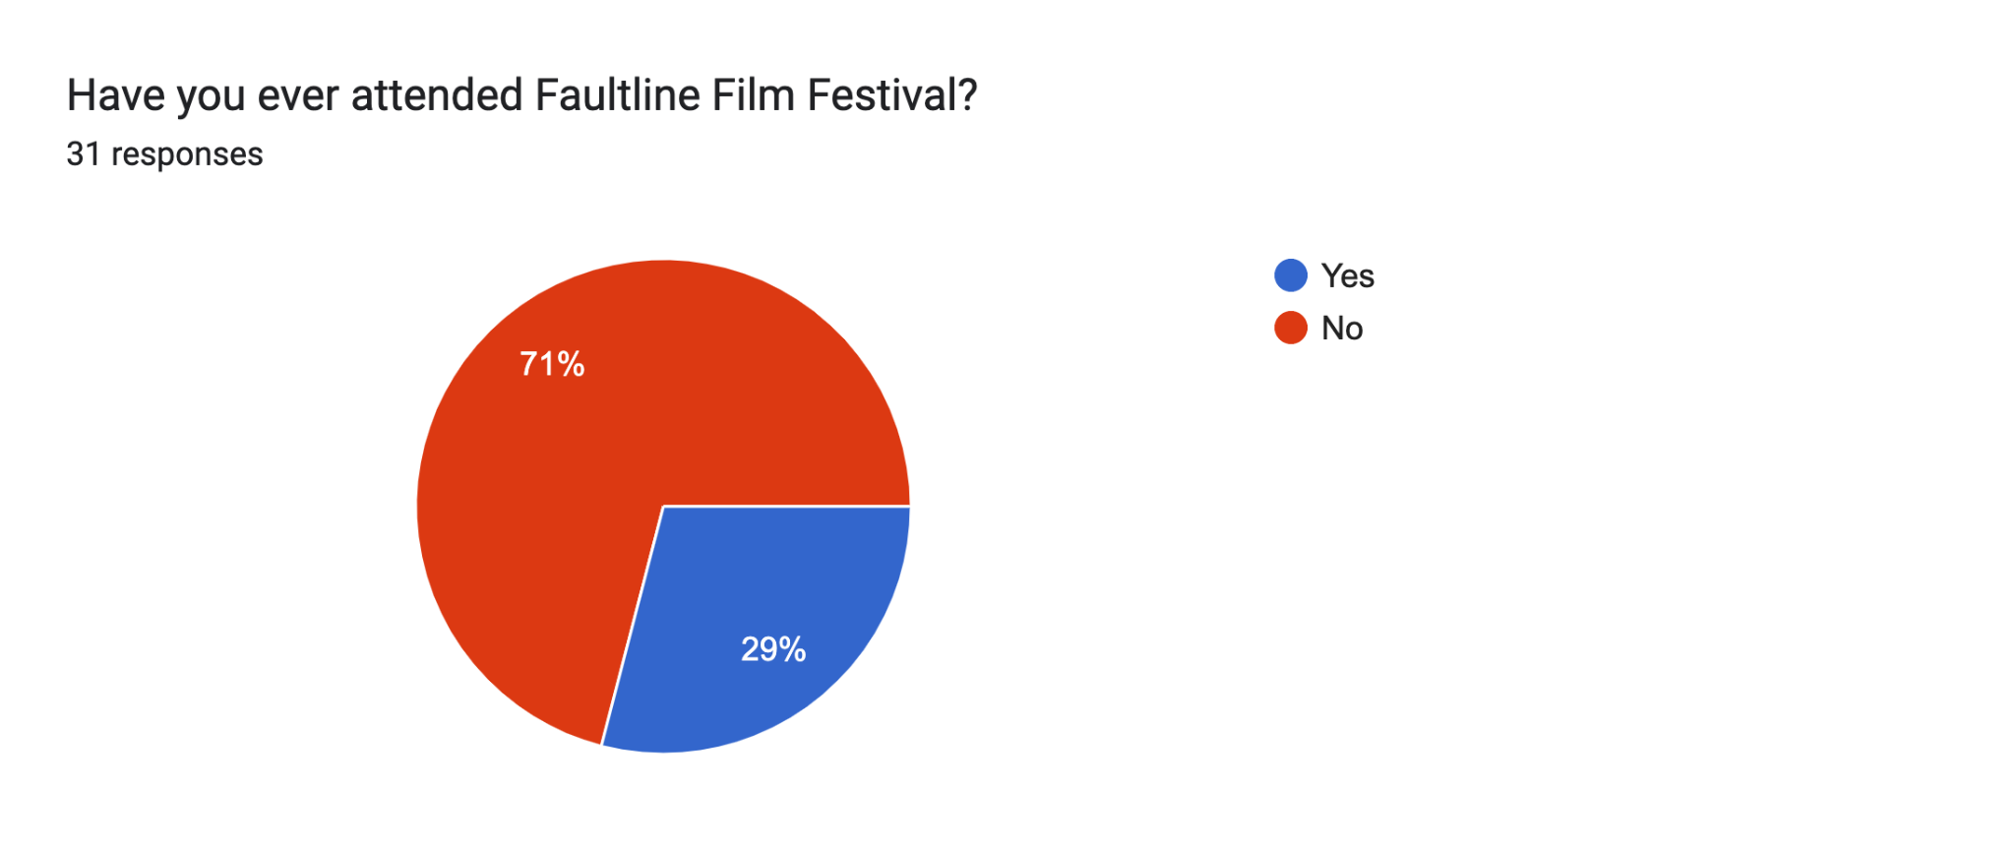
The first question on the survey asks if the participant has ever attended the Fault Line Film Festival. With more than ⅔ saying no, and only ⅓ saying yes, it may be wise to further promote. This finding suggests Fault Line should spend more time promoting.

FINDING TWO:

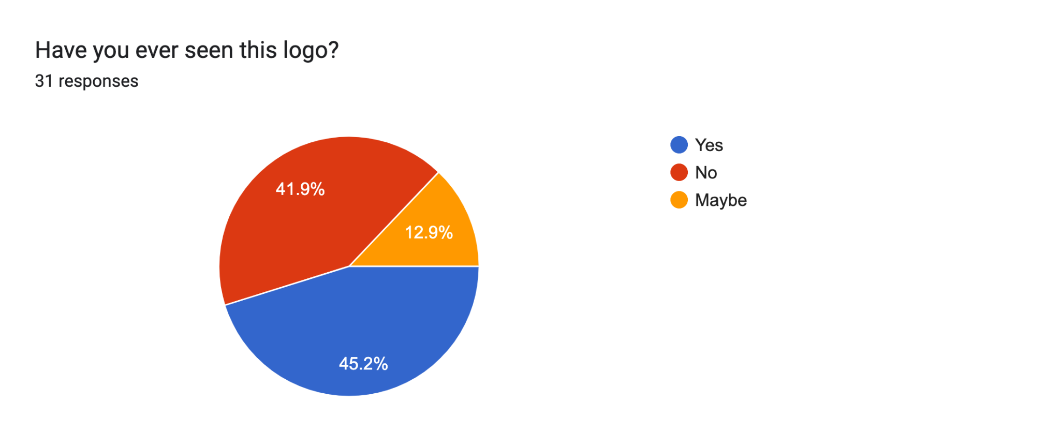
The second question asks if the participant has ever seen this logo: 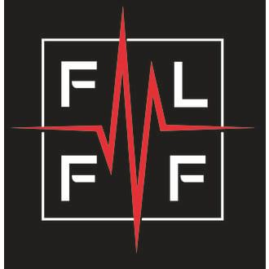
With around 40 percent saying no, and 45 percent saying yes, with a 13 percent margin of error, it is safe to say that the logo should be advertised more. With the previous finding being that 71% have never attended Fault Line, this finding may show that, with 41.9% of participants never having seen the Fault Line Film Festival logo, there may be a correlation between the two. This suggests that Fault Line may need to promote the logo more frequently in the future.

FINDING THREE:
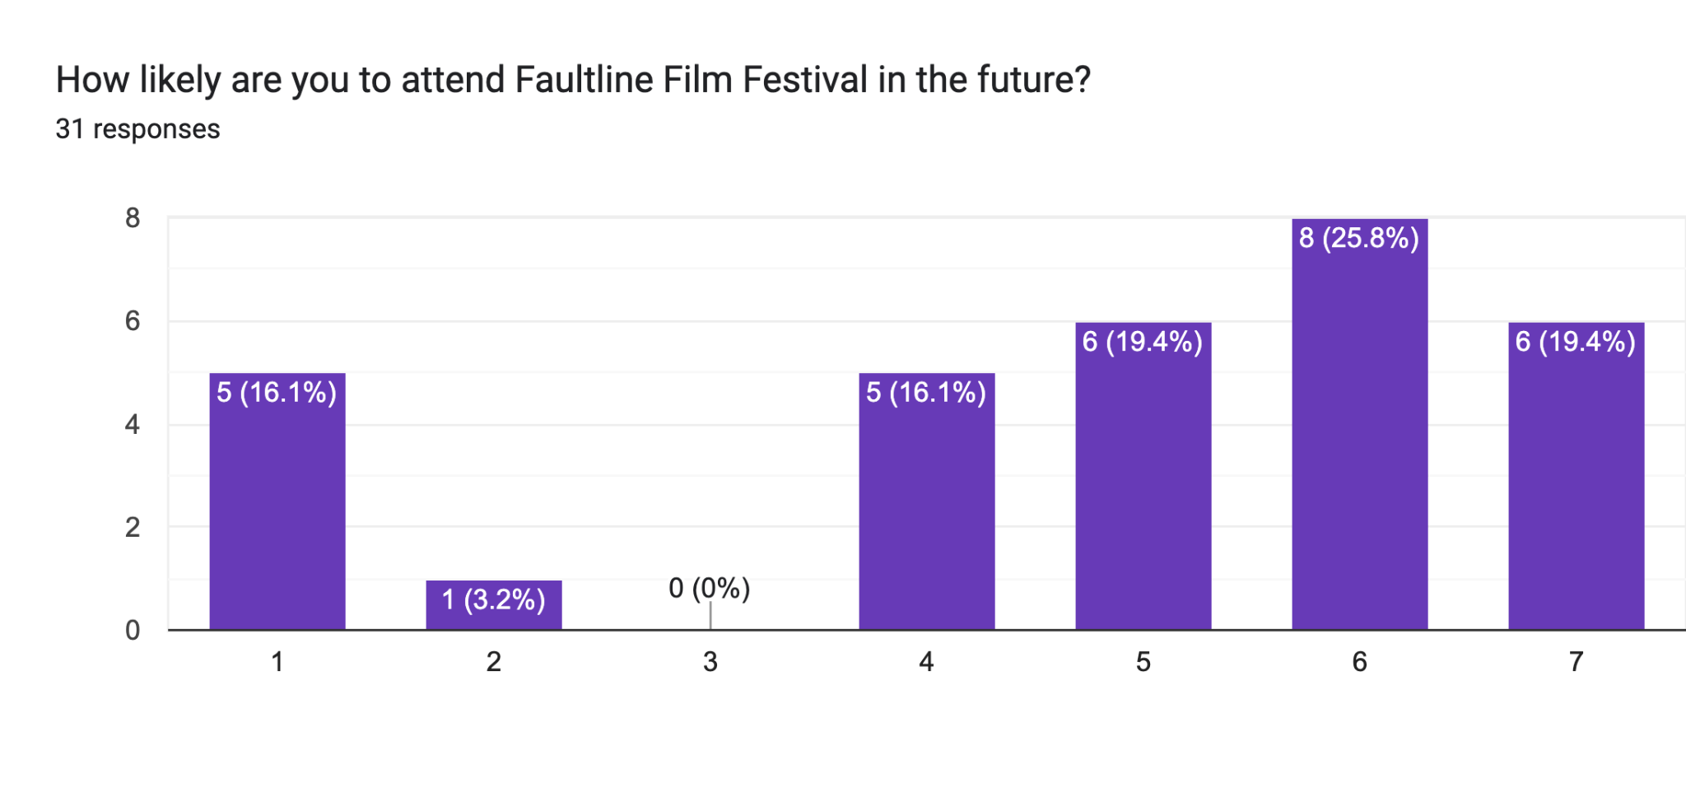On the “1” side of the scale, the option was “Extremely unlikely” and the opposite side was “Extremely likely”.

The curve on this poll is extremely beneficial. With the latter half of the scale being the highest percentages, this means that most people would be more than likely to re-attend the Fault Line Film Festival. This suggests that people who DO go to Fault Line, enjoy it. The problem is people who do not go, do not have the beneficial experiences to say they will go again.

FINDING FOUR:
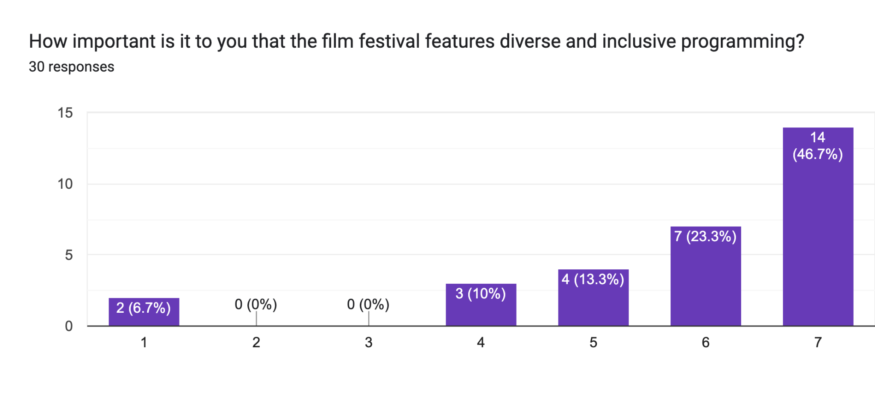
The “1” side of the scale said “Not Important at All” and the opposite side said “Extremely Important”.

This poll shows that a majority of the people who took the survey do care about diversity and inclusion, with a combined 83.3% of participants on the right, positive response side of the poll. This shows us that Fault Line should include as much diversity as possible, as the vast majority of participants found diversity extremely important.
FINDING FIVE:
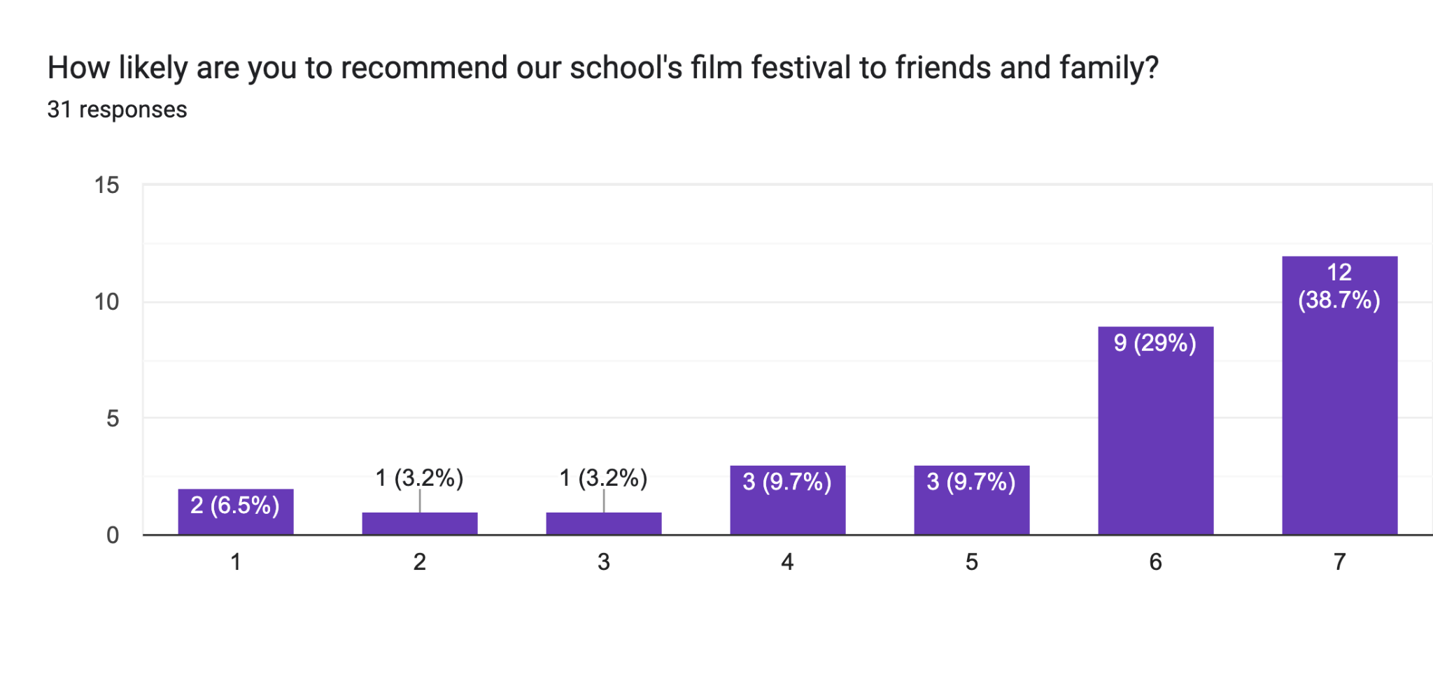
The “1” side of this poll question was “Extremely unlikely” and the opposite side was “Extremely likely”.

This poll is a good sign. With 77.4% of participants leaning towards recommending the Fault Line Film Festival to friends and family. This shows that if we increase publicity of the festival, the people that it reaches are more than likely to promote the show for you. This takes out a lot of the promotional issues. Having people advertise for you is always less work and money than promoting yourself. According to findings one and two, however, there needs to be an initial push for advertisement of the festival, as right now, not many people know of the festival.

CONCLUSION:

With all of the above information, I conclude the people who attend the Fault Line Film Festival care about diversity and inclusion, and most would attend the festival again. The main problem is in the marketing of the event, where people do not know about Fault Line as much as they maybe should. An initial push of advertisement would be needed to get people to know about the festival, and then according to Finding 5, most people would do the leg work of promoting the show themselves. Despite positive sentiments among those who attend, there's a clear marketing challenge highlighted by the substantial proportion of respondents who haven't attended or are unaware of the festival. Further promotion and outreach efforts could bridge this gap.

Below, Kendal will go into detail about how people who SUBMIT their films to Fault Line feel about the process.

Fault Line Submission:
FINDING ONE:
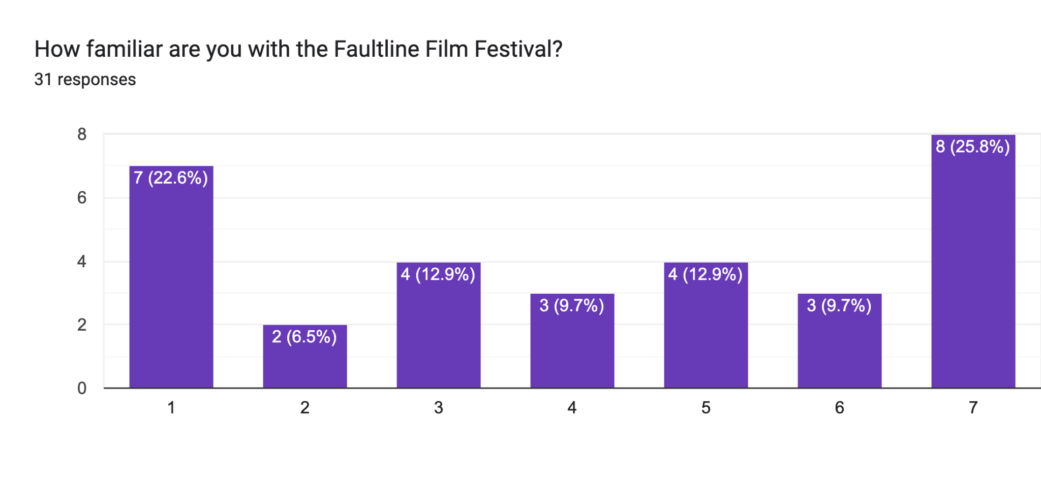On the “1” side of the poll question, the choice was “Extremely unfamiliar”, and the other side was “Extremely familiar”. There seems to be a bit of opposition to this vote. 22% have no idea what the Fault Line Film Festival is, whereas 25% are extremely informed about the Film Festival. There’s also a little bit of neutrality within 2-6. This shows an extreme: most people either are extremely familiar or unfamiliar with the festival.

FINDING TWO:
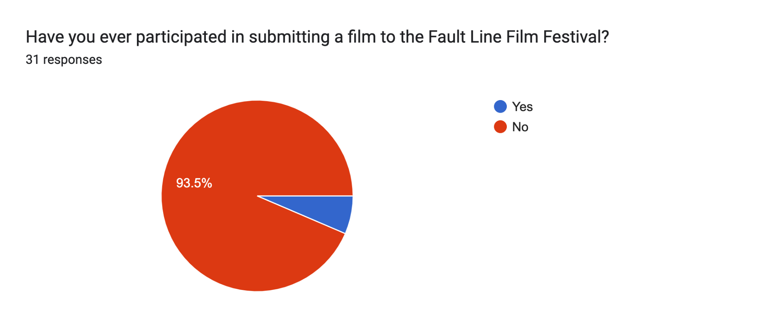6.5% are the select few who have participated in the submission to Fault Line.
93.5% have not. The majority number, 93.5% have either simply gone to the festival, have never gone, or do not know about the festival.
FINDING THREE: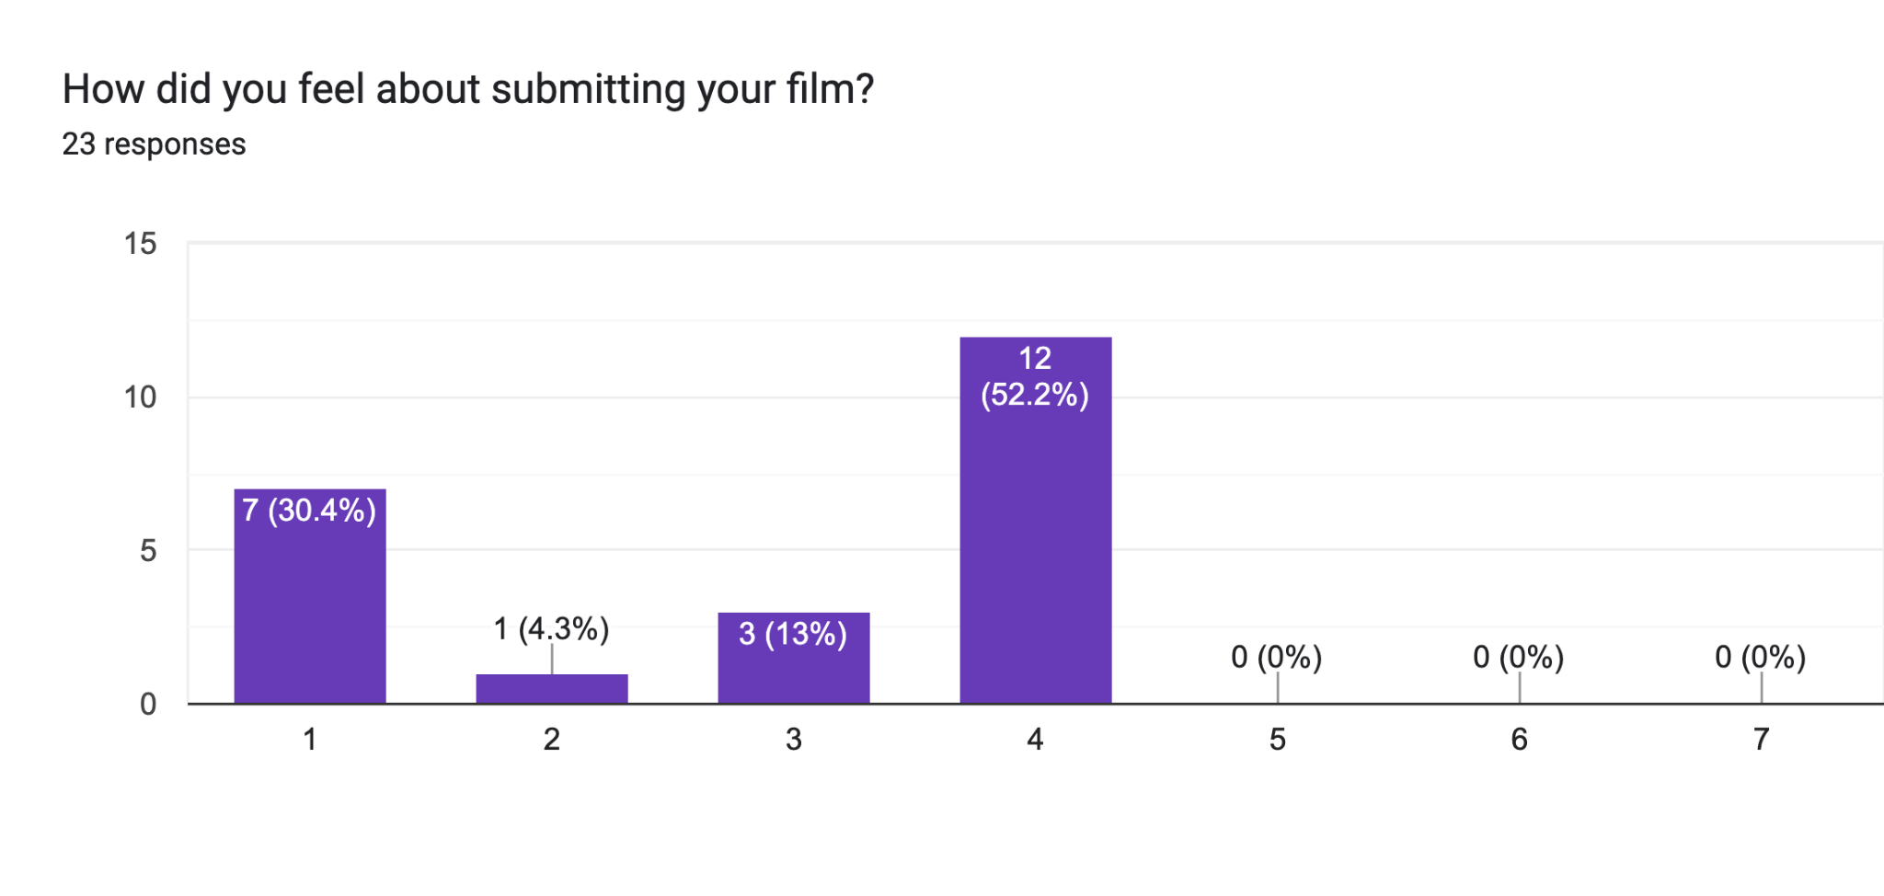The “1” side of the scale represents “It was extremely easy” and the opposite side is “It was extremely hard”.

Based on the survey responses, it's evident that while a significant proportion (30.4%) didn't submit their films or expressed difficulty in submission, the majority (52.2%) rated their submission experience positively with a score of 4. The smaller percentages opting for ratings 2 (4.3%) and 3 (13%) indicate mixed sentiments. Notably, there were no responses at the higher end of the scale (5-7), reflecting diverse perspectives on the Fault Line Film Festival submission process. This may also correlate with Finding Two, where we saw that an overwhelming number of participants had never submitted to the festival, and this finding shows that not a single participant found the submission process easy. This suggests that Fault Line must make their submission application and following requirements easy if at all possible, and potentially more people would submit to the festival.

FINDING FOUR:

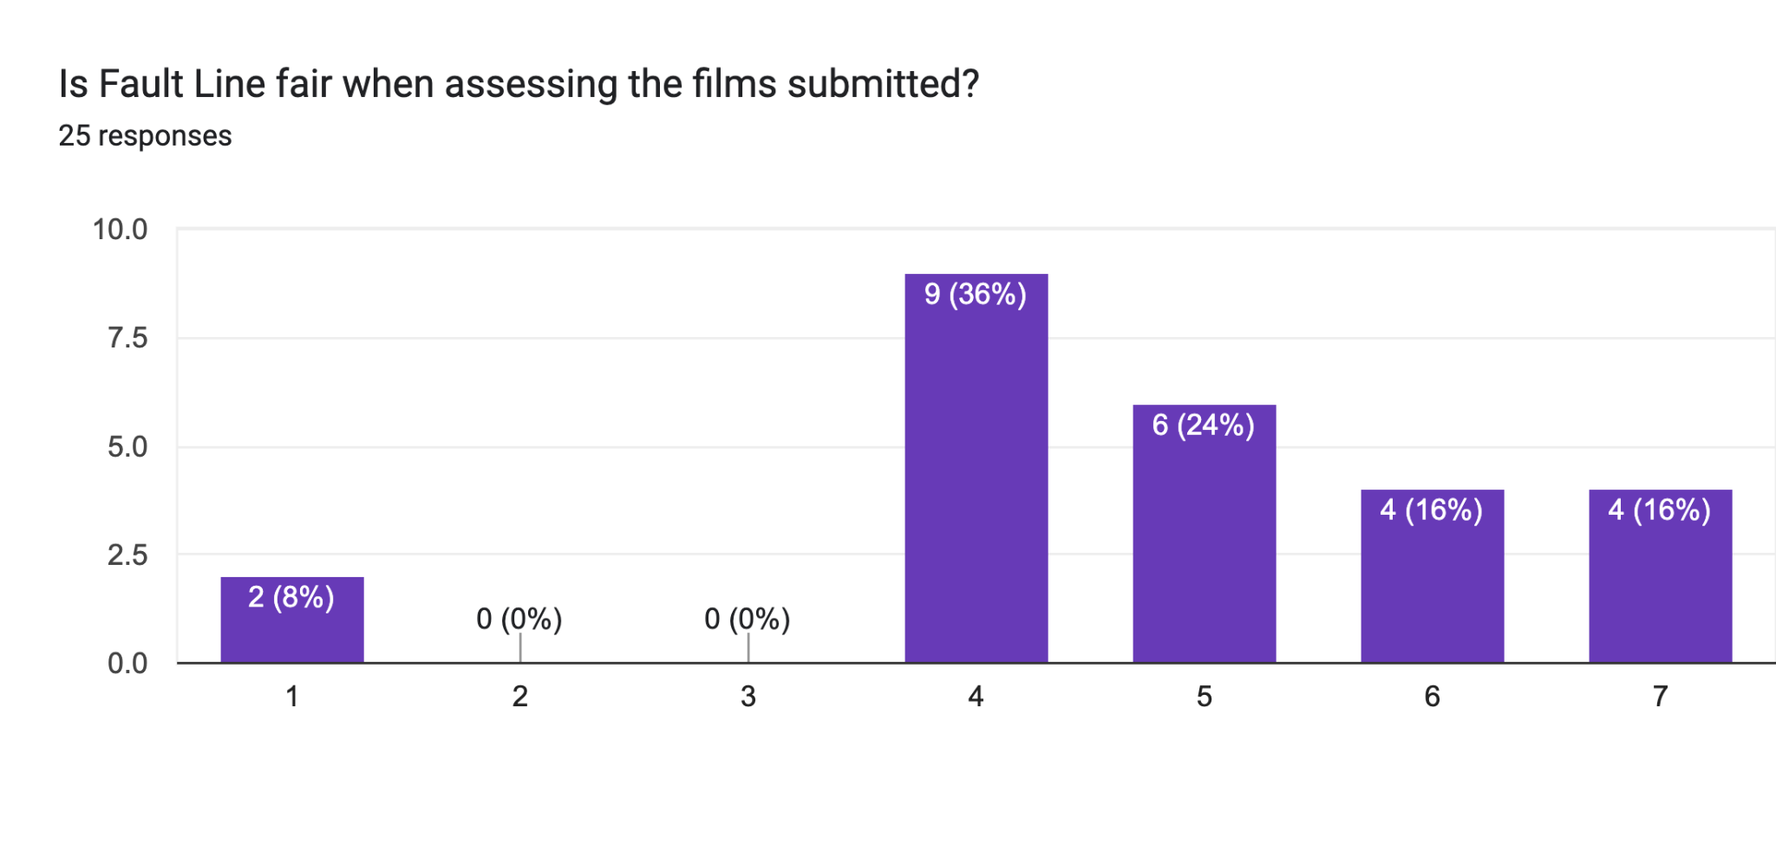The “1” side of the poll was “Absolutely not” and the opposite was “Absolutely”.

Notably, no respondents rated the fairness as a 2 or 3. Instead, a significant portion (36%) rated it at a moderate level (4), while a notable percentage (24%) rated it slightly higher (5). Additionally, there were considerable proportions who rated the fairness relatively high (16% each for 6 and 7). These findings suggest a generally positive perception of fairness among participants, albeit with varying degrees of confidence in the festival's assessment process.

CONCLUSION:
To conclude, the analysis reveals valuable insights into the Fault Line Film Festival and its film submission participants. Insights into the submission process and perceptions of fairness provide valuable feedback for festival organizers to consider. Overall, these findings offer a comprehensive understanding of the Fault Line Film Festival's audience and areas for improvement in its operations and outreach efforts.

Team Information

Ryan Fredrick
Mass Communication: Television and Film
Phone Number: (636) 515-8716
Email: rsfredrick1s@semo.edu

Kendal Lewis
Mass Communication: Television and Film
Phone Number: (901) 728-9616
Email: kelewis2s@semo.edu

Appendix
Codes Used:
Fault Line attendees. Students/Spectators who have attended or submitted their film to Fault Line.

SEMO College Students and Everyday People

Influence - Influencing people to go to view the Fault Line Film Festival if they have not already.

Target Audience - SEMO Students and Everyday People

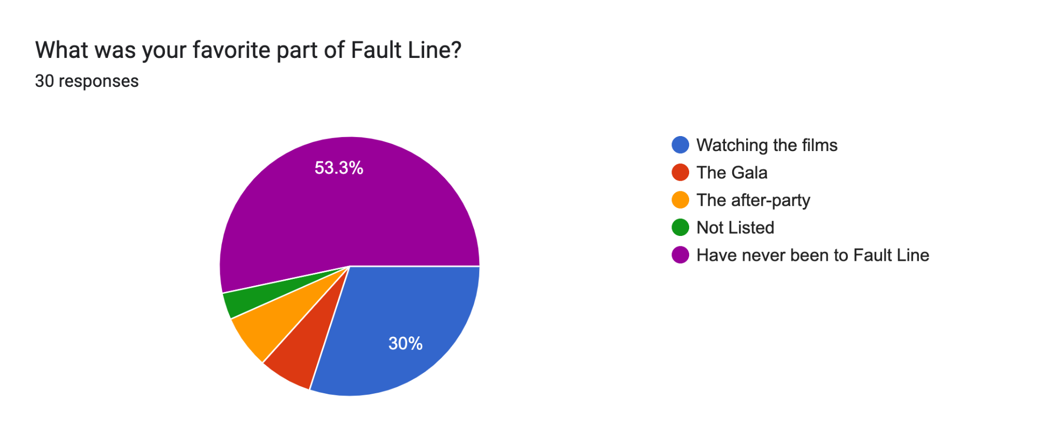
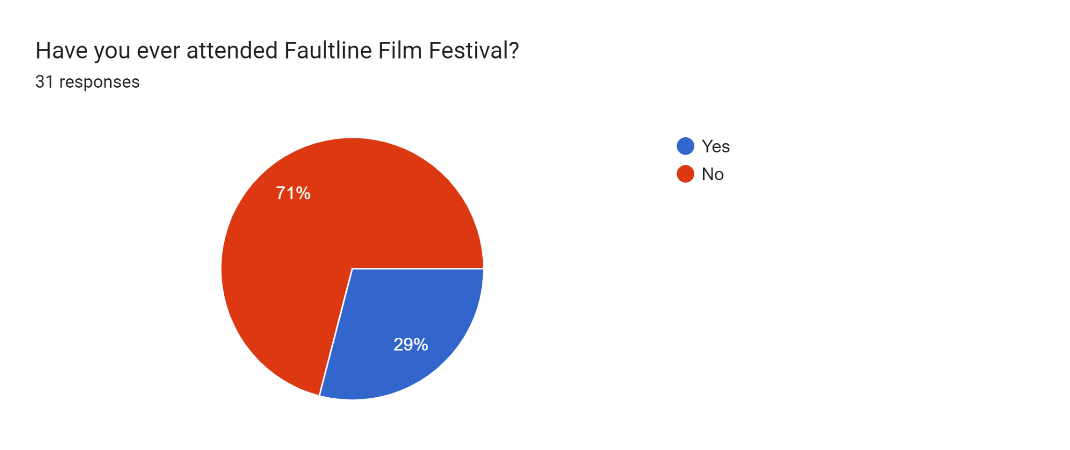
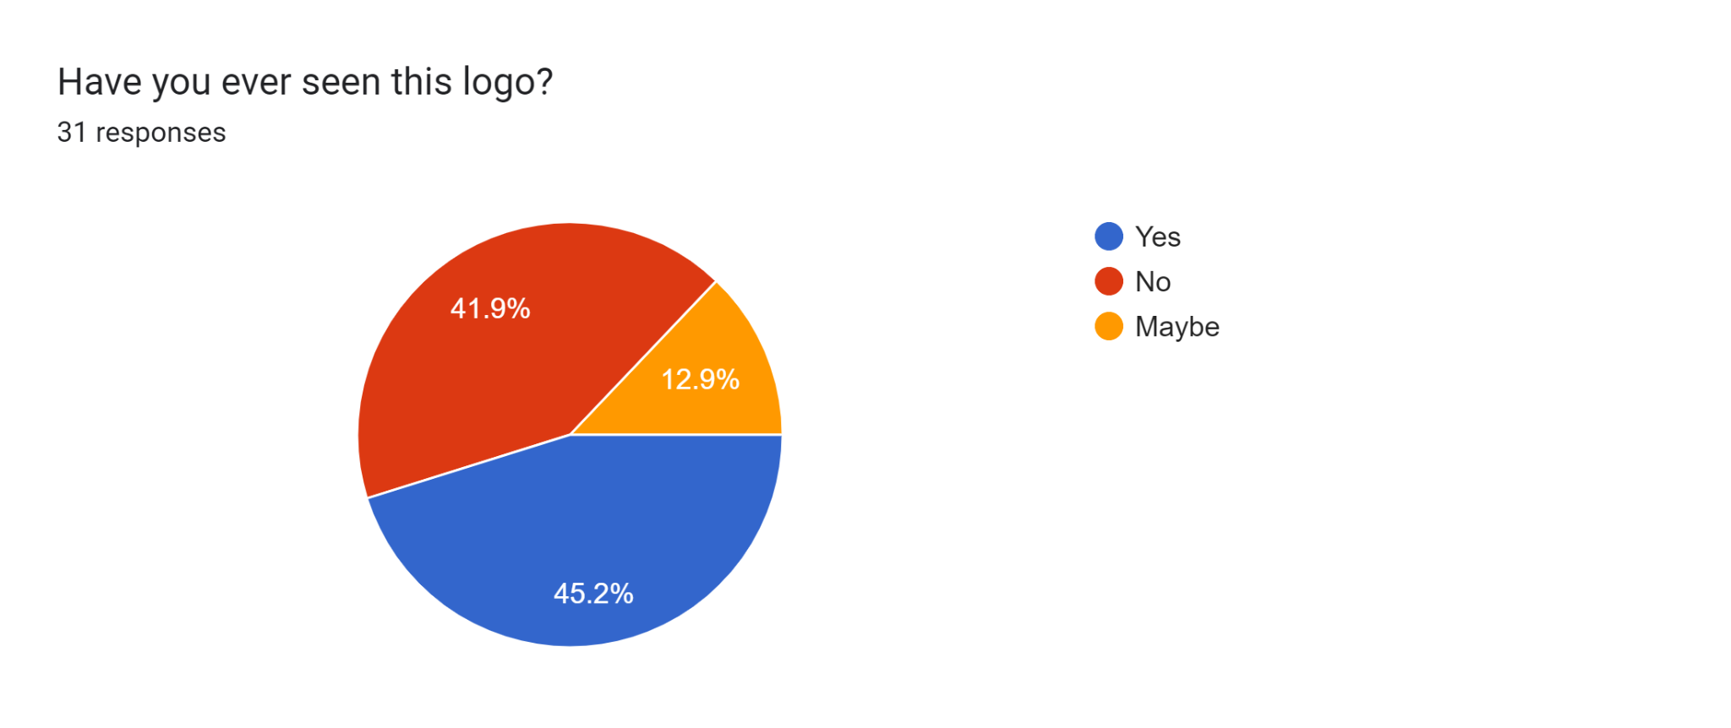
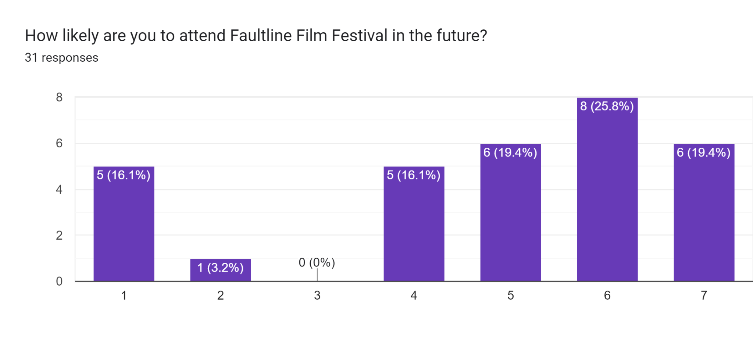
Extremely Unlikely Extremely Likely
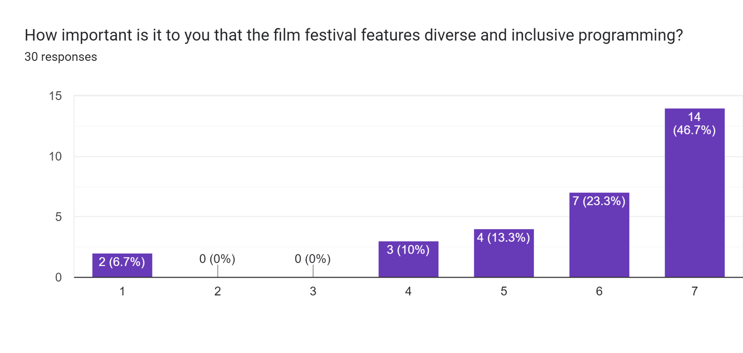
Not Important at all Extremely important
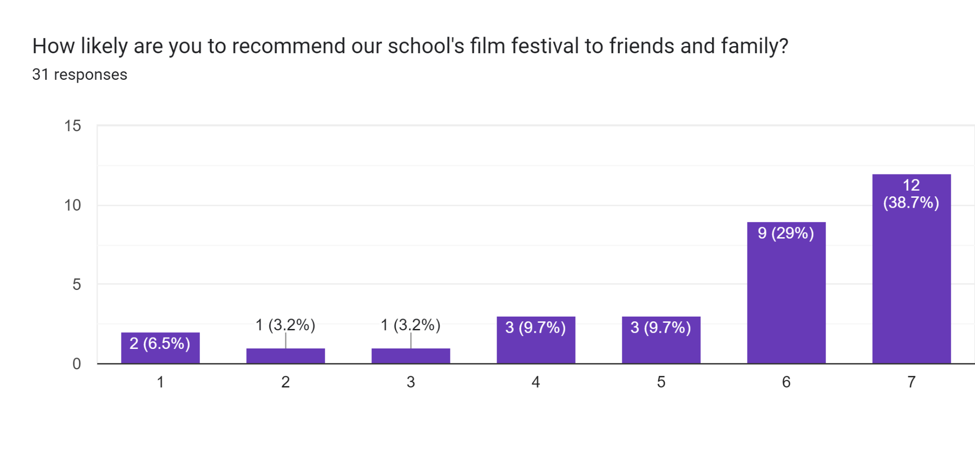
Extremely unlikely Extremely likely

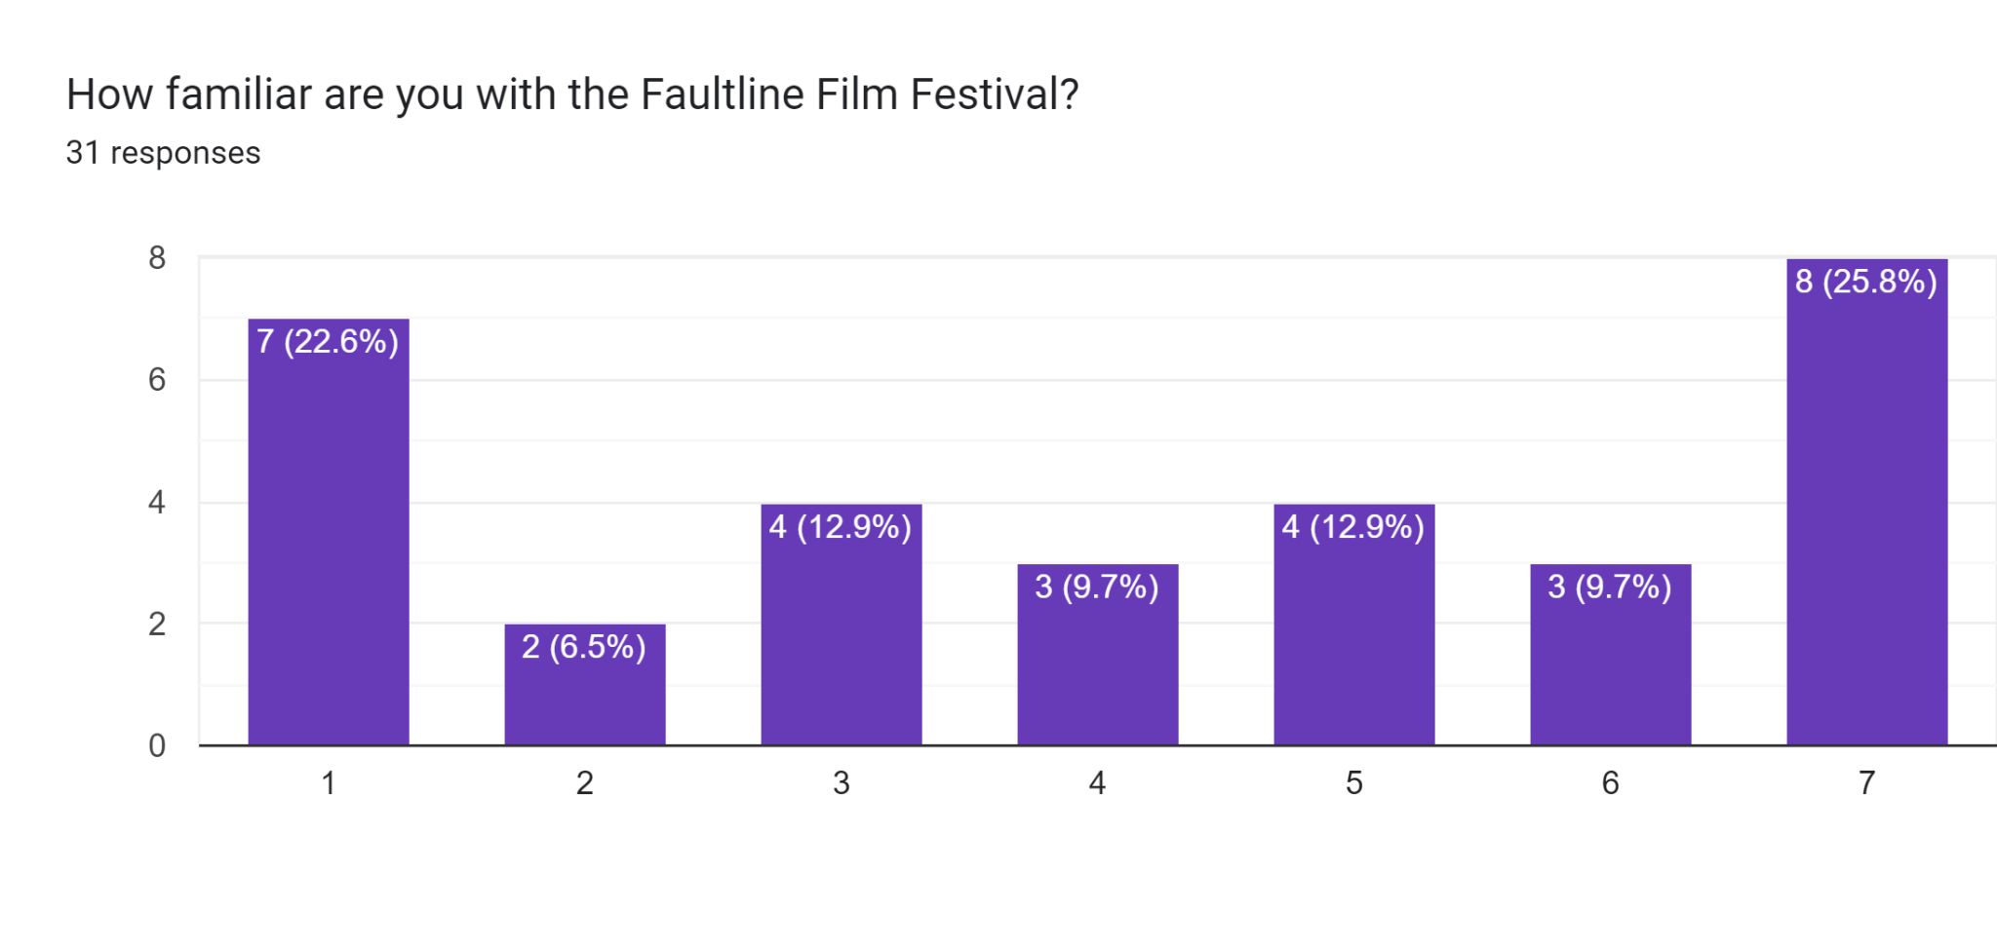
Extremely unfamiliar Extremely familiar

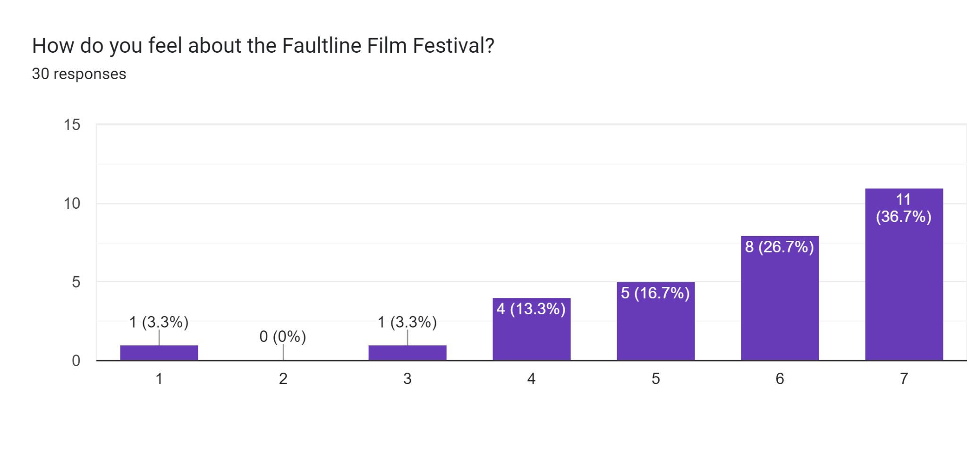
Extremely dislike Extremely like

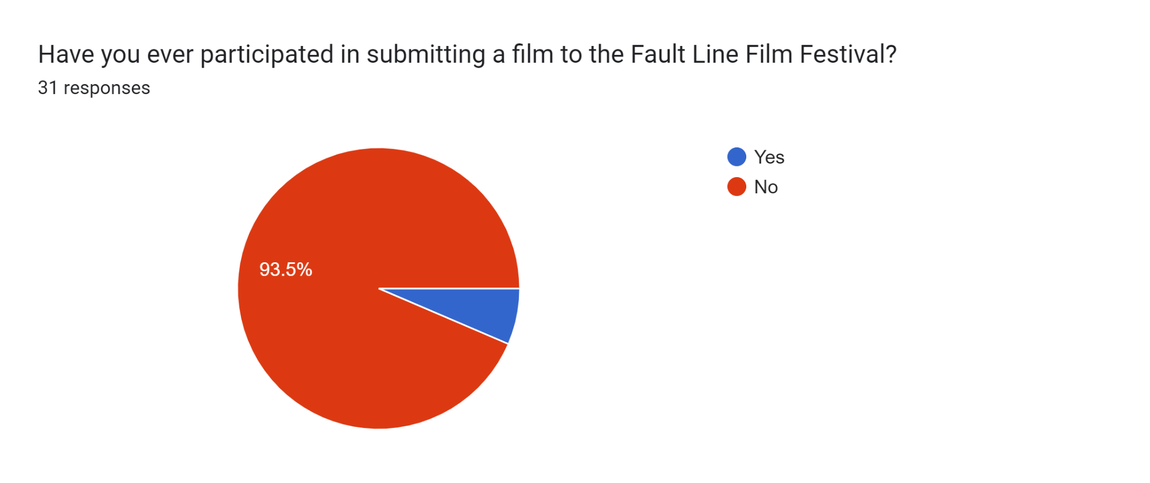
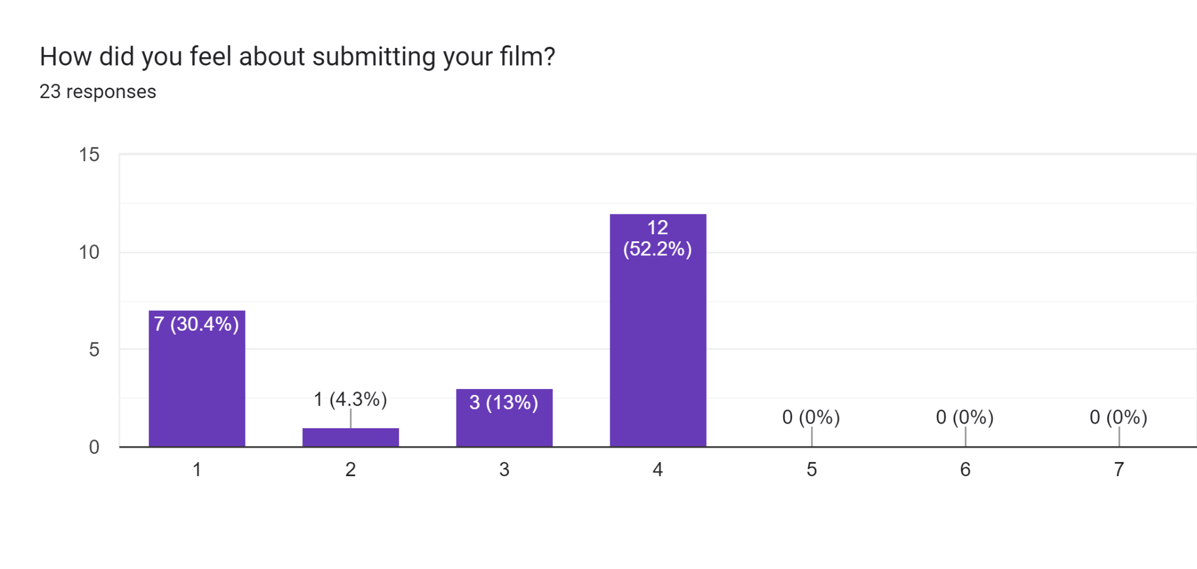
It was extremely easy It was extremely hard

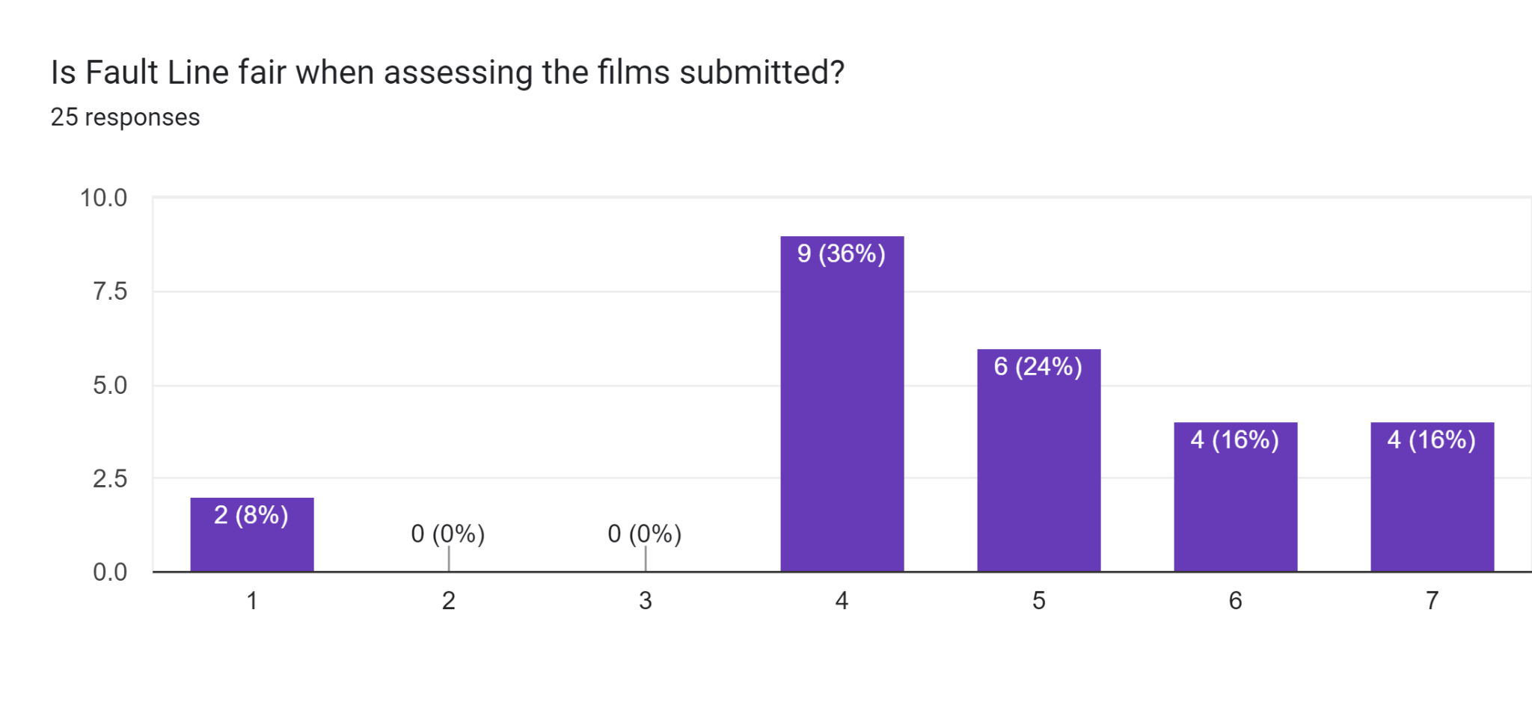
Absolutely not Absolutely
